STUDENT PERFORMANCE ANALYSIS USING POWER BI

A Project Report
Submitted in partial fulfillment of the
Requirements for the award of the Degree of
BACHELOR OF SCIENCE (INFORMATION TECHNOLOGY)
By
Miss.Saloni Pratap Desai
Seat Number

Under the esteemed guidance of
Mrs. Akshata Godkar

DEPARTMENT OF INFORMATION TECHNOLOGY
SHRI PANCHAM KHEMRAJ MAHAVIDYALAYA
(Affiliated To University Of Mumbai)
SAWANTWADI , 416510
MAHARASHTRA
2024 – 2025

SHRI PANCHAM KHEMRAJ MAHAVIDYALAY
(Affiliated To University Of Mumbai)
SAWANTWADI-MAHARASHTRA-416510

DEPARTMENT OF INFORMATION TECHNOLOGY

CERTIFICATE

This is to certify that the project entitled, "Student Performance Analysis using PowerBI", is bonafied work of Miss.Saloni Pratap Desai bearing submitted in partial fulfillment of the requirements for the award of degree of BACHELOR OF SCIENCE in INFORMATION TECHNOLOGY from University of Mumbai.

Internal Guide Coordinator

External Examiner

Date: College Seal

Abstract
Title: Data Analysis for Identifying Top-Performing Students
This project leverages data analysis techniques to identify top-performing students from academic data. Using the school's student performance records as the primary data source, information was systematically gathered and organized into various datasets. These datasets were processed and cleaned using Python’s Pandas library, ensuring accuracy and consistency for analysis.
The project employs Data Analysis Expressions (DAX) and predefined parameters to evaluate student performance across multiple dimensions, including academic achievements, extracurricular activities, and overall progress. These criteria provide a solid foundation for the analysis, allowing for the extraction of valuable insights into student performance.
The findings offer detailed insights into student achievements, highlighting standout performers across different categories. These insights form the basis for the project’s conclusion, helping educators and administrators make informed decisions about student recognition and future learning strategies. The visual representation in Power BI enhances the understanding of student metrics, supporting data-driven decision-making within the educational institution. This project integrates Python-driven data preprocessing and Power BI visualization, offering a comprehensive approach to evaluating and understanding student performance.

ACKNOWLEDGEMENT

I am sincerely thankful to Mrs. Akshata Godkar for their expert guidance, unwavering support, and constructive feedback throughout the project. Their mentorship played a pivotal role in shaping the project's direction and ensuring its successful completion.
I extend my heartfelt thanks to Google and its affiliated services (e.g., Google Sheets, Google Forms) for providing the essential tools and infrastructure to collect, analyze, student performance data. The ease of access to these platforms greatly facilitated the data collection process.

Thank you …

Saloni Pratap Desai
TY BSC InformationTechnology

DECLARATION

I here by declare that the project entitled, “Student Performance Analysis” done at place where the project is done, has not been in any case duplicated to submit to any other university for the award of any degree. To the best of my knowledge other than me, no one has submitted to any other university.
The project is done in partial fulfillment of the requirements for the award of degree of
(BACHELOR OF SCIENCE (INFORMATION TECHNOLOGY) to be submitted as final semester project as part of our curriculum

(Miss. Saloni Pratap Desai)

TABLE OF CONTENTS
1.Introduction 1
1.1 Background 8
1.2 Purpose 8
1.3 Objectives 8
1.4 Scope 8
1.5 Overview 9
2.Survey of Technologies 10
2.1 Required Tools for analysis 10
2.1.1 Excel 10
2.1.2 Python 10
2.1.3 Power BI 10
3.PROJECT METHODOLOGY 11
3.1 CRISP-DM 11
3.2 CRISP-DM Flowchart 12
3.3 Six Super Steps for Data Processing 13
4. Data Description 14
4.1 Data Source 14
4.3 Data Overview 14
4.3.1 Student_Details 14
4.3.2 Parents_Details File 15
4.3.3 FY_Performance File 15
4.3.4 SY_Performance File 15
4.3.5 TY_Performance File 16
4.3.6 Extracurricular_Activities File 16
4.3.7 Attendance_Details File 16
4.4 Data Types 19
4.5 Data Sample 21
5. Implementation and Testing 22
5.1 Retrive 22
5.1.1 Data Collection 22
5.1 2 Data Retrival 22
5.1 3 Data Gathering Outcome 22

5.1 Introduction to Data Cleaning and Preprocessing 22
5.2 Some Data Cleaning and Preprocessing Techniques Used in Context of Project 22
5.3 Data Cleaning and Preprocessing Tasks Related to This Project 23
5.4 Cleaning and Preprocessing using Python Pandas Library 24

List of Tables
Table 1. Student_Details 19
Table 2. Parents_Details 19
Table 3. FY_Performance 20
Table 4. SY_Performance 20
Table 5. TY_Performance 30
Table 6. Extracurricular_Activities 30
Table 7. Attendance_Details 31
Table 8.FY_Top_10_Performerce 31
Table 9.SY_Top_10_Performerce 31
Table 10.FY_Top_10_Performerce 31

List of Figures
Figure 1 : CRISP-DM Flowchart 12
Figure 2 : Student_Details 20
Figure 3 : Parents_Details 20
Figure 4 : FY_Performance 20
Figure 5 : SY_Performance 20
Figure 6: TY_Performance 21
Figure 7: Extracurricular_Activities 21
Figure 8 Attendance_Details: 21
Figure 9.FY_Top_10_Performerce 31
Figure10.SY_Top_10_Performerce 31
Figure 11.FY_Top_10_Performerce 31

1.Introduction

1.1 Background
Student performance analysis assesses learning outcomes, identifying areas for improvement by considering academic metrics, attendance, extracurricular activities, and annual household income. This holistic approach reveals relationships between socio-economic status and academic achievement.

1.2 Purpose
This project analyzes student performance, extracurricular activities, attendance, and household income to identify learning patterns, knowledge gaps, and inform targeted interventions for holistic development and improved academic success, regardless of socio-economic background.

1.3 Objectives
This project helps students succeed by analyzing their performance, attendance, and activities to identify areas for improvement and provide targeted support, ensuring all students thrive academically and personally

1.4 Scope
The project collects data through a Google Form, gathering information on student performance, attendance, and extracurricular activities. The data is then cleaned and integrated to ensure accuracy and consistency, providing a comprehensive understanding of student learning patterns, knowledge gaps, and areas for improvement.

1.5 Overview

This project undertakes a comprehensive data analysis to uncover the intricacies of student performance in the Department of Information Technology at Shree Pancham Khemraj Mahavidyalaya, with the primary objective of identifying the key factors that significantly influence student success. By leveraging a robust dataset comprising demographic and academic variables.
we aim to develop a predictive model that can accurately forecast student performance, thereby enabling educators and administrators to make informed decisions. Through a rigorous exploratory data analysis, we will uncover trends, patterns, and correlations between various attributes, and employ feature selection techniques to distill the most relevant factors contributing to student success.

This research will provide actionable insights for educators to refine their teaching strategies, identify at-risk students, and optimize resource allocation to foster an conducive learning environment. Moreover, the findings will inform curriculum development, facilitate targeted interventions, and enhance student support services. By harnessing the power of data analysis.
This project aims to connect data analysis with academic success, leading to significant improvements in student learning, teacher effectiveness, and school growth. By using data to inform decision-making, educators can identify areas for improvement, develop targeted strategies, measure progress, and enhance the overall quality of education
While acknowledging potential limitations related to data quality and model assumptions, this study endeavors to contribute meaningfully to the existing body of knowledge on student performance analysis, offering valuable implications for educators, administrators, and students alike.

2.Survey of Technologies

Required Tools for analysis

2.1.1 Excel
Microsoft Excel is a powerful spreadsheet software widely used for data analysis, calculations, and visualization. Excel provides a user-friendly interface for storing , organizing, and manipulating data , making it a versatile tool for managing datasets. With built in formulas, and features like Power Query, Excel facilitates data analysis tasks, allowing users to explore, clean , and transform data for further insights. Excel’s charting and graphing tools enable users to create visually compelling representations of data, aiding in interpretation and communication od analysis results.

2.1.2 Python
Python language serves as primary tool and framework of various aspects of your project including data cleaning, preprocessing, analysis, and visualization. It can be utilized to use python libraries such as pandas, to clean and preprocess data. Python offers a wide range of data analysis libraries, including NumPy, SciPy for numerical computations. Python libraries such as Matplotlib, Seaborn, Plotly enable you to create various data visualizations. Python can be integrated into Power BI through custom scripts or Python Visuals, allowing you to bring python generated visualizations and calculations into your Power BI reports.

2.1.3 Power BI
Power BI is a robust business intelligence tool designed for visualizing and analyzing data, offering comprehensive suite of features for creating interesting dashboards and reports. Power BI seamlessly integrates with various data sources allowing users to pull data from diverse databases, Excel files, cloud services, and more providing centralized platform for comprehensive analysis. The tools capabilities extend to dynamic and interactive reporting, enabling users to explore and gain insights from complex datasets through features such as slicers, filters, and drill down options.

3.PROJECT METHODOLOGY

3.1 CRISP-DM
The CRISP-DM (Cross-Industry Standard Process for Data Mining) is a widely used framework for guiding data mining and analytics projects. The CRISP-DM consist of six main phases, each representing a stage in the project life cycle.
1.Business Understanding:-
i)Objectives : Define the project objectives and requirements from a business perspective.
ii) Activities : Formulate business goals, Assess the situation , Determine data mining goals.
2.Data Understanding:-
i)Objective : Collect and explore data to get insights into its characteristics and quality.
ii)Activities : Collect initial data , Describe Data , Explore Data
3.Data Preparation:
i)Objectives : Select, clean, and transform data to create a suitable dataset for analysis.
ii)Activities : Select data, clean data, construct data, Integrate Data.
4.Modelling:
i)Objectives : Apply modelling techniques to build and assess predictive or descriptive models.
ii)Activities : Select Modelling technique , Build model , Asses model.
5.Evaluation:
i)Objective : Assess the model’s performance and determine its effectiveness in meeting the business objectives.
ii)Activities : Evaluate results, Review process, Determine next steps.
6.Deployment:
i)Objective : Implement the result of the analysis into the business environment.
ii)Activities : Plan deployment, Monitor and maintain the model, Produce final report

3.2 CRISP-DM Flowchart

Figure 1 : CRISP-DM Flowchart
Business Understanding

Data Understanding

Data Preparation

Modelling
Deployment

Evaluation

3.3 Six Super Steps for Data Processing

1) Retrieve: This involves collecting data from diverse sources like databases, APIs, or files. It's the initial step where information is gathered for analysis, often through queries or extraction methods.
2) Access: Once retrieved, data needs to be made available for processing. Access involves ensuring the collected data is properly stored and accessible, possibly by implementing security measures and organizing it for ease of use.
3) Process: Data processing encompasses cleansing, analyzing, and manipulating the gathered information. It involves techniques such as statistical analysis or algorithms to extract meaningful insights or patterns.
4) Transform: After processing, data might need to be restructured or reformatted to fit specific requirements. Transformation involves converting data into a more suitable format for further analysis or application.
5) Organize: This step involves arranging the transformed data into a structured and coherent format. It may include categorizing, indexing, or labeling data for easier retrieval and analysis.
6) Report: Finally, reporting involves presenting the analyzed and organized data in a comprehensible manner. This often includes creating visualizations, summaries, or reports that convey insights or findings for decision-making or dissemination.

4. Data Description

4.1 Data Source
A Google Form was designed and distributed to 100 students in the Department of Information Technology, Shree Pancham Khemraj Mahavidyalaya, to collect data on their academic performance. The responses were automatically collected and stored in a Google Sheets document.

4.2 Data Overview
The dataset consists of seven Excel files, containing information on
a] Student_Details
b] Parents_Details
c] FY_Performance
d] SY_Performance
e] TY_Performance
f] Extracurricular_Activities
g] Attendance_Details

4.3.1 Student_Details Table
This file contains demographic information about students in the Department of Information Technology, Shree Pancham Khemraj Mahavidyalaya.
Columns:
Student_ID | Unique identifier for each student.
Student_Name | Name of the student
Date_of_birth | Date of birth of the student.
Gender | Gender of the student(Male/Female/Other).
S_Phone_No | Student's phone number.
Email | Student's email address
Address | Student's residential address.
Class | Student's current class/grade.
Income | Student's family income.

4.2.2 Parents_Details Table
This file contains information about the parents/guardians of students in the Department of Information Technology
Student_ID | Unique identifier for each student (matches Student_ID in Student_Details).
Father_Name | Name of the student's father.
F_Phone_No: | Father's phone number.
Parents_Email | Email address of the parents/guardians.
Mother_Name: | Name of the student's mother.
M_Phone_No: | Mother's phone number.

4.2.3 FY_Performance Table
This table contains the first-year (FY) academic performance data for students
Columns:
Student_ID | Unique identifier for each student (foreign key).
10th_Total_Marks | Total marks obtained in 10th standard
10th_Percentage | Percentage obtained in 10th standard
12th_Total_Marks | Total marks obtained in 12th standard.
12th_Percentage | Percentage obtained in 12th standard.

4.2.4 SY_Performance Table
This table contains the second-year (SY) academic performance data for students
Columns
Student_ID: | Unique identifier for each student
Sem_1 | Semester 1 result (regular/repeater).
S1_Total_Marks: | Total marks obtained in Semester 1.
S1_Grade: | Grade obtained in Semester 1.
S1_Credits: | Credits earned in Semester 1.
S1_CGPA | Point Average in Semester 1
Sem_2: | Semester 2 result (regular/repeater).
S2_Total_Marks: | Total marks obtained in Semester 2.
S2_Grade | Grade obtained in Semester 2.
S2_Credits | Credits earned in Semester 2.
S2_CGPA | Point Average in Semester 2.

4.2.5 TY_Performance Table
This table contains the third-year (TY) academic performance data for students
Columns:
Student_ID: | Unique identifier for each student
Sem_3 | Semester 3 result (regular/repeater).
S3_Total_Marks: | Total marks obtained in Semester 3.
S3_Grade: | Grade obtained in Semester 3.
S3_Credits: | Credits earned in Semester 3.
S3_CGPA | Point Average in Semester 3
Sem_4 | Semester 3 result (regular/repeater).
S4_Total_Marks: | Total marks obtained in Semester 4.
S4_Grade | Grade obtained in Semester 4.
S4_Credits | Credits earned in Semester 4.
S4_CGPA | Point Average in Semester 4.

4.2.6 Extracurricular_Activity Table
This table contains information about the extracurricular activities participated in by students.
Columns:
Student_ID: | Unique identifier for each student
Which_Activity: | Specific activity within the chosen category
Achievement | Notable achievements or awards received in the extracurricular activity
4.2.6 Attendance Table
This table stores attendance records for students
Student_ID: | Unique identifier for each student
Attendance | Attendance percentage for the student.

4.4 Data Types
Table 1. Student_Details
Column Name | Data Type
Student_ID | Whole Number
Student_Name | Text
Date_of_birth | Date
Gender | Text
S_Phone_No | Whole Number
Email | Text
Address | Text
Class | Text
Income | Whole Number

Table 2. Parents_Details
Column Name | Data Type
Student_ID | Whole Number
Father_Name | Text
F_Phone_No | Whole Number
Parents_Email | Text
Mother_Name | Text
M_Phone_No | Whole Number

Table 3.FY_Performance
Column Name | Data Type
Student_ID | Whole Number
10th_Total_Marks | Decimal Number
10th_Percentage | Decimal Number
12th_Total_Marks | Decimal Number
12th_Percentage | Decimal Number

Table 4.SY_Performance
Column Name | Data Type
Student_ID | Whole Number
Sem_1 | Text
S1_Total_Marks | Decimal Number
S1_Grade | Text
S1_Credits | Whole Number
S1_CGPA | Decimal Number
Sem_2 | Text
S2_Total_Marks | Decimal Number
S2_Grade | Text
S2_Credits | Whole Number
S1_CGPA | Decimal Number

Table 5.TY_Performance
Column Name | Data Type
Student_ID | Whole Number
Sem_3 | Text
S3_Total_Marks | Decimal Number
S3_Grade | Text
S3_Credits | Whole Number
S3_CGPA | Decimal Number
Sem_4 | Text
S4_Total_Marks | Decimal Number
S4_Grade | Text
S4_Credits | Whole Number
S4_CGPA | Decimal Number

Table 6.Extracurricular_Activity
Column Name | Data Type
Student_ID | Whole Number
Extracurricular_Activity | Text
Which_Activity | Text
Achievements | Text

Table 7. Attendance
Column Name | Data Type
Student_ID | Whole Number
Class | Text
Attendance | Integer

4.5 Data Sample
Figure 2 : Student_Details
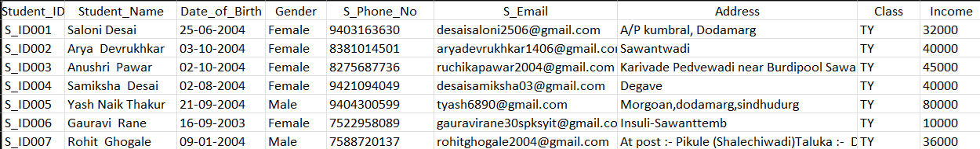
Figure 3 : Parents_Details
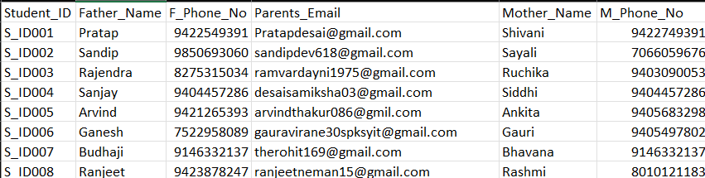
Figure 4: FY_Performance
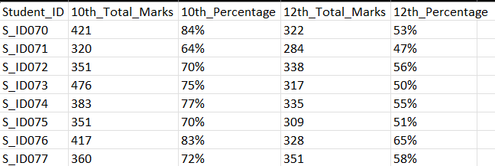
Figure 5 : SY_Performance
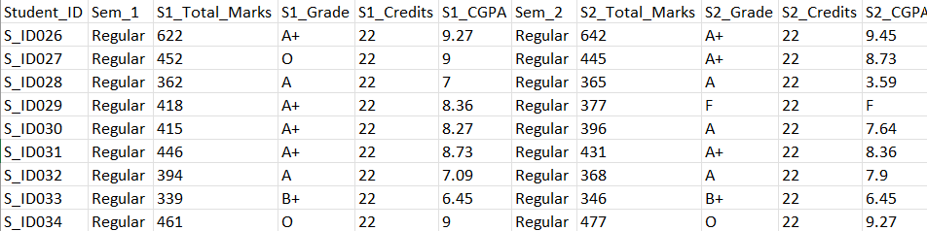
Figure 6 : TY_Performance
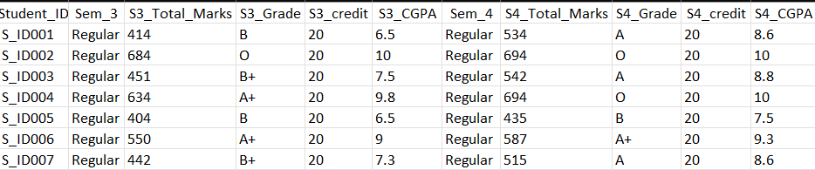
Figure 7 : Extracurricular_Activity
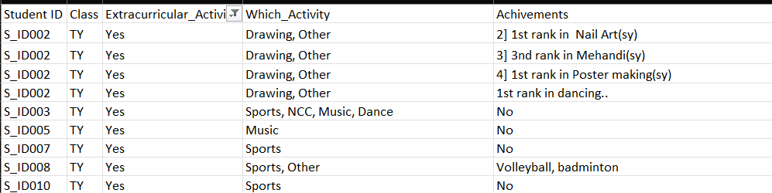
Figure 8:Attendance
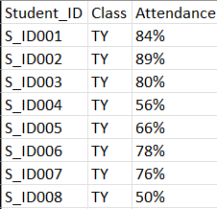

5) Data Cleaning and Preprocessing

5.1 Introduction to Data Cleaning and Preprocessing
Data cleaning and preprocessing are crucial steps for preparing data for analysis. Data cleaning involves identifying and cleaning errors, inconsistencies, and missing values in the dataset. This includes handling duplicates, dealing with outliers, and ensuring data uniformity.
Preprocessing focuses in transforming raw data into a format suitable for analysis. Tasks involve normalization, scaling, feature selection, and encoding categorical variables, making dataset ready for modeling and analysis.
By effective cleaning and preprocessing data, analysts ensure the reliability and accuracy of their findings, leading to more robust and meaningful conclusions in the data analysis project.

5.2 Some Data Cleaning and Preprocessing Techniques Used in Context of Project
1.Column Labelling : Column labeling involves assigning clear and descriptive names to dataset columns for easy understanding and usability during analysis. It includes using concise, consistent, and unambiguous names without special characters or spaces, ensuring clarity and ease of use for analysts and algorithms.
2.Column Deletion or Column Removal : Column deletion, also known as column removal or dropping columns, involves the elimination of specific columns from a dataset. This technique is employed when certain columns are redundant, irrelevant, or provide no value to the analysis or modeling process.
3.Text Data Cleaning : Text data cleaning involves preparing textual information for analysis by removing irrelevant or noisy elements and standardizing the text.
4.Handling Missing Values : Handling missing values refers to the process of managing or dealing with incomplete or absent data entries within a dataset during data preprocessing.
5.Data Deduplication : Data deduplication is the process of identifying and removing duplicate or redundant entries within a dataset to ensure data accuracy and consistency.
6.Data Conversion : Data conversion involves transforming data from one format or structure to another, enabling compatibility between systems, applications, or different versions of software.
7.Data Standardization : Data standardization is the process of transforming data into a uniform format or structure to enhance consistency, comparability, and compatibility across different datasets or systems.
8.Feature Scaling : Normalizing or Standardizing features to have the same scale.
9.Feature Extraction : Creating new features from existing data.
10.One-Hot Encoding : Converting categorical variables into binary(0/1) format.
11.Data Transformation : Applying mathematical transformations , such as logarithms or exponentials.

Data Cleaning and Preprocessing Tasks Related to This Project

1) Data Transformation: Decimal values in the dataset were converted to percentages to facilitate easier interpretation.
2) Data Filtering: The " Extracurricular_Activity" column was filtered to only include rows where students responded with "Yes", allowing for focused analysis on students who participated in such activities.
3) Student IDs were repeated for students participating in multiple activities.
Note:-These preprocessing steps were performed using Excel, ensuring the dataset was refined and relevant for further analysis.

5.4 Cleaning and Preprocessing using Python Pandas Library
Requirement – Need to Install Pandas package in Python.
1)To Load excel files in pandas – used ‘pandas.read-excel()’ function
2) For Generate random attendance (70-90)
3) Created 'Student ID' column with unique, incrementing IDs (S_ID001, S_ID002, ...)
4) Split the original 'Student Form (Responses)' Excel file into 7 separate files (Student Details, Parents Details, FY/TY/SY Performance, Extracurricular Activity, and Attendance Details) and converted each to CSV format using pandas, ensuring data organization and compatibility for further analysis
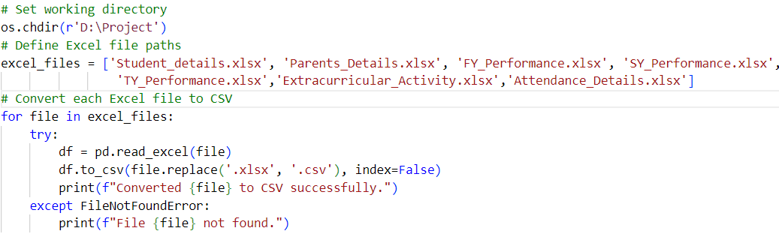
i)Student_Details File:-
This line of code replaces specific student names in the 'Student_Name' column with a standardized format, updating 'saloni pratap desai' to 'Saloni Desai'.
ii) Parents_Details File:
Updated Mother Name column by replacing incorrect phone number entry ('9403071084') with corresponding correct name ('Saili') to ensure data accuracy.

4) To Find Top 30 Students: FY, SY, TY Best Performers
1. Average Calculation: Calculated the average marks for each student by adding the total marks obtained in Sem 1 and Sem 2 and dividing by 2.
2. Data Processing: Created a separate Excel file, "Top_Performers.xlsx", with the following columns:
- Student ID
- Average Marks
3. Top Performers Identification: Filtered the data to identify the top 10 performers for each academic year (FY, SY, TY) based on their average marks.

